# AWS Athena is used for querying S3 bucket contents, such as flow logs etc. It gives a mechanism to query S3 buckets using standard SQL commands.

* **We also covered Athena Service in Chapter 9 and section 9.4**

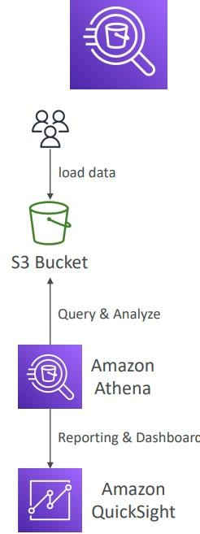

# Data obtained in Athena can then be migrated to multiple data ingestion systems by creating Lambda functions.

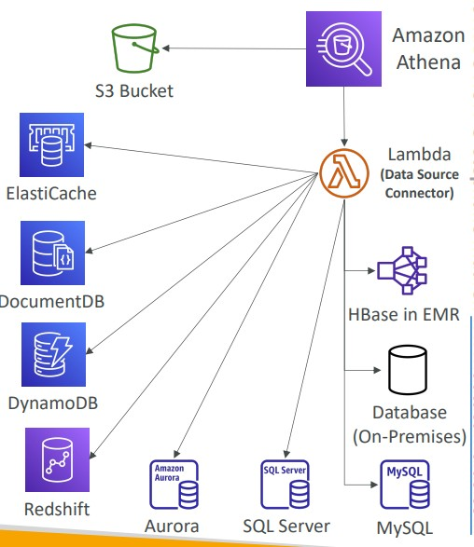

Kinesis Analytics: Amazon Kinesis cost-effectively processes and analyzes streaming data at any scale as a fully managed service. With Kinesis, you can ingest real-time data, such as video, audio, application logs, website clickstreams, and IoT telemetry data, for machine learning (ML), analytics, and other applications. (aws.com)

* **If we know the data sources, we can create streaming applications from it within AWS.**

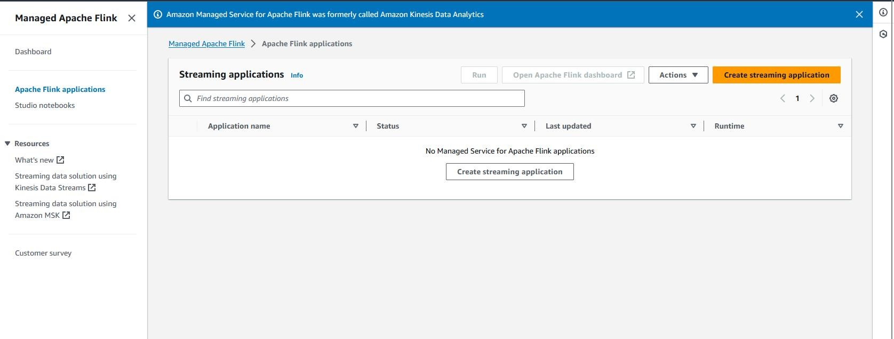

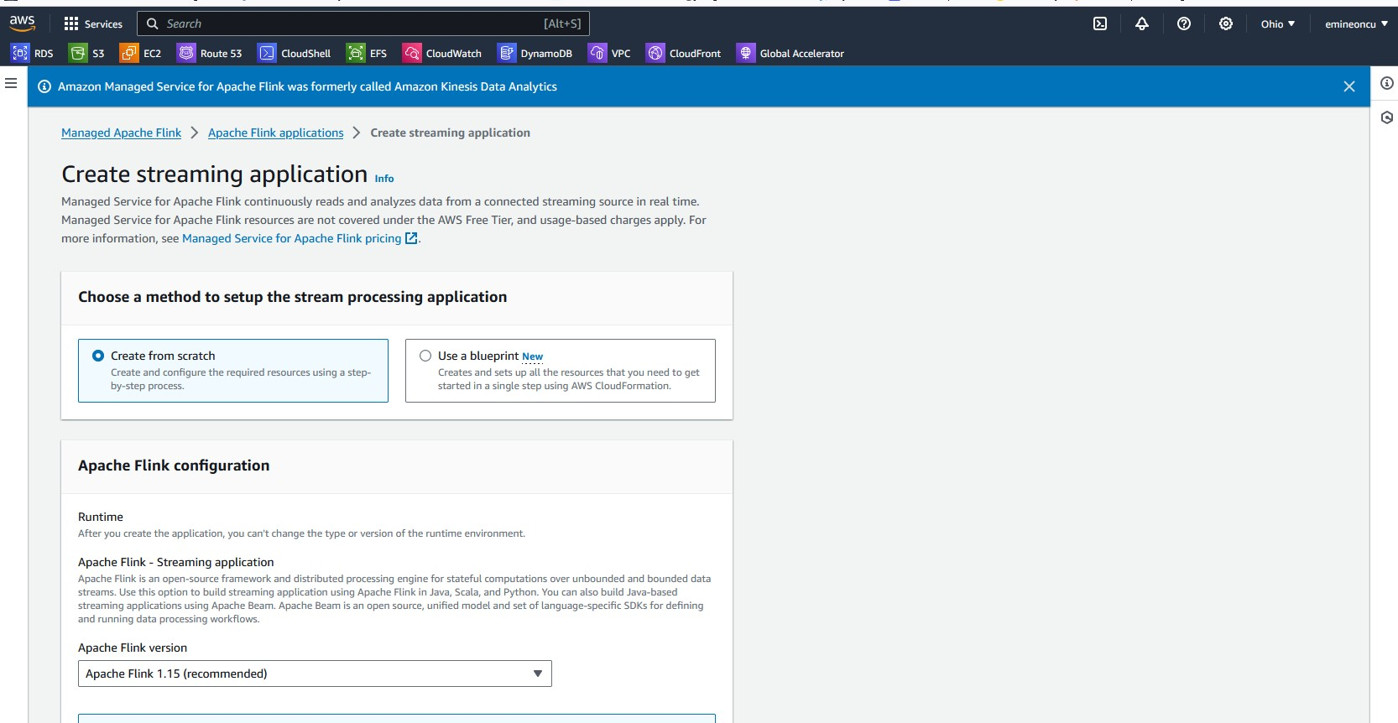

* **Kinesis Data Streams**

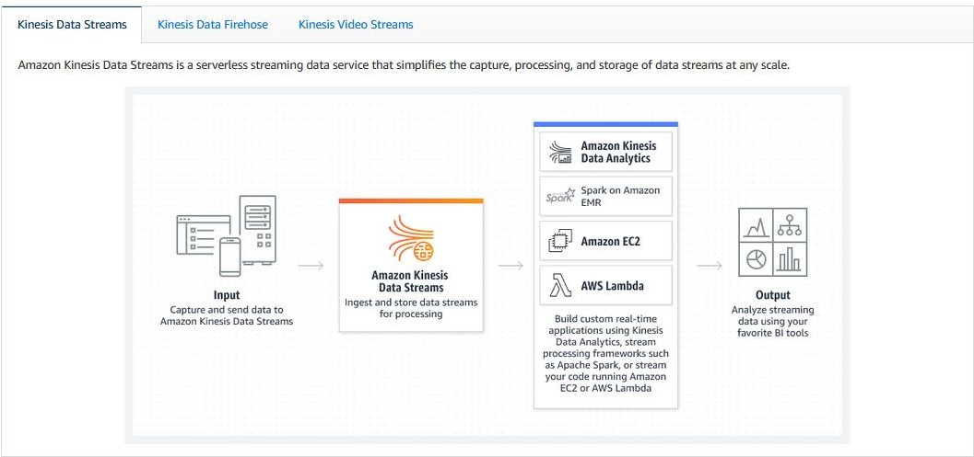

# Kinesis Data Firehose

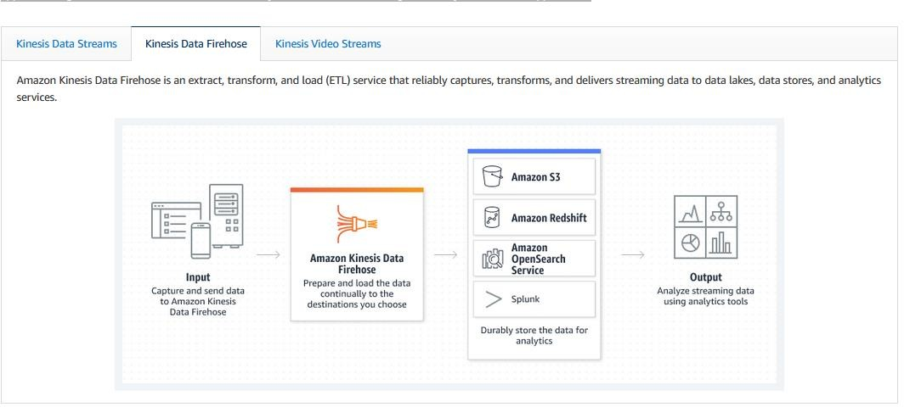

* **Kinesis Video Streams**

